Half Yearly Progress Report on Research Work carried out from 28.09.2011 to 27.03.2012
Name and address of the candidate : P. Mohandass
Reg. No. P8851
PG and Research Dept. of Chemistry
Saraswathi Narayanan College
Madurai-22.

Occupation if any and address : Associate Professor of Chemistry
Saraswathi Narayanan College
Madurai-22.

Name, designation and address of the : Dr. K. Radhakrishnan
Guide Associate Professor of Chemistry
Saraswathi Narayanan College
Madurai-22.

College where the candidate carried : PG and Research Dept. of Chemistry
out the research Saraswathi Narayanan College
Madurai-22.

Whether the candidate has paid annual
Research fee (mention amount, date of : No
remittance, place of bank, etc.)

Detailed one page report on the progress : Separate sheet Attached
of research work carried out by the
candidate (attach separate sheet)

Remark, if any by the guide : Nil

Signature of the candidate Signature of the research supervisor

Half Yearly Progress Report on Research Work carried out from 28.09.2011 to 27.03.2012

Preparation of 4′-substituted 2-benzylidene-1,3-indandiones.
2-benzylidene-1,3-indandione and its substituted compounds were prepared by the reported procedure. To the calculated amount of the appropriate benzaldehyde (12.5 mM) and 1,3-indandione (12.5 mM) in warm ethyl alcohol was added a 10% solution of sodium hydroxide (catalytic amount) and the reaction mixture stirred for 2 h to 3 h and left overnight. The solvent was removed under vacuum. The resulting crude product was purified by column chromatography.

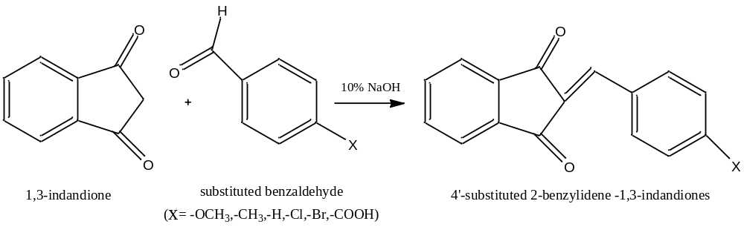

Signature of the research supervisor

